AI FITTRACK API
Project Documentation

1. Project Title: FitTrack AI – Personalized Fitness Recommendations Powered by AI
2. Team ID: SWTID-2026-7645
3. Team Leader: Katherin K & katherinkatherin753@gmail.com
4. Team Members: Hariharani S & mahalakshmidurga10@gmail.com
5. Team Members: Subhiksha N & subhiksha265@gmail.com
6. Team Members: Roselin Kaviya D & roselinkaviya2006@gmail.com
7. Team Members: Rithika & rithikakr143@gmail.com
1. INTRODUCTION
FitTrack AI is an intelligent fitness tracking and recommendation system designed to help users manage their workout records and receive personalized fitness guidance. The system allows users to securely register and log in, add and manage workout records, search previous workouts, and view their fitness information. Google Gemini AI is integrated to generate personalized workout recommendations and fitness insights based on user details and workout statistics. MongoDB is used to store user and workout data, while Mongoose manages the database structure. JWT authentication is used to protect secured APIs and bcrypt.js is used for password hashing. The backend follows a modular MVC architecture using Node.js and Express.js, making the application organized, maintainable, and scalable. Overall, FitTrack AI combines secure user management, workout tracking, database storage, and AI-powered recommendations in a single platform.
2. SOURCE CODE
{
"name": "ai-fittrack-api",
"version": "1.0.0",
"description": "RESTful Fitness Tracking API with Google Gemini AI integration",
"main": "src/server.js",
"scripts": {
"start": "node src/server.js",
"dev": "nodemon src/server.js"
},
"dependencies": {
"@google/genai": "^2.10.0",
"bcryptjs": "^2.4.3",
"cors": "^2.8.5",
"dotenv": "^16.4.5",
"express": "^4.19.2",
"jsonwebtoken": "^9.0.2",
"mongoose": "^8.4.1",
"morgan": "^1.10.0"
},
"devDependencies": {
"nodemon": "^3.1.2"
}
} Environment variables:
PORT=5000
MONGO_URI=mongodb://localhost:27017/fittrack
JWT_SECRET=super_secret_fittrack_jwt_key_12345
GEMINI_API_KEY= AQ.Ab8RN6LcXJfC2GZPcd6AtZ_EdL2EfKVZCcGBoPqRY3P_2FC7CA
SCREENSHOT:

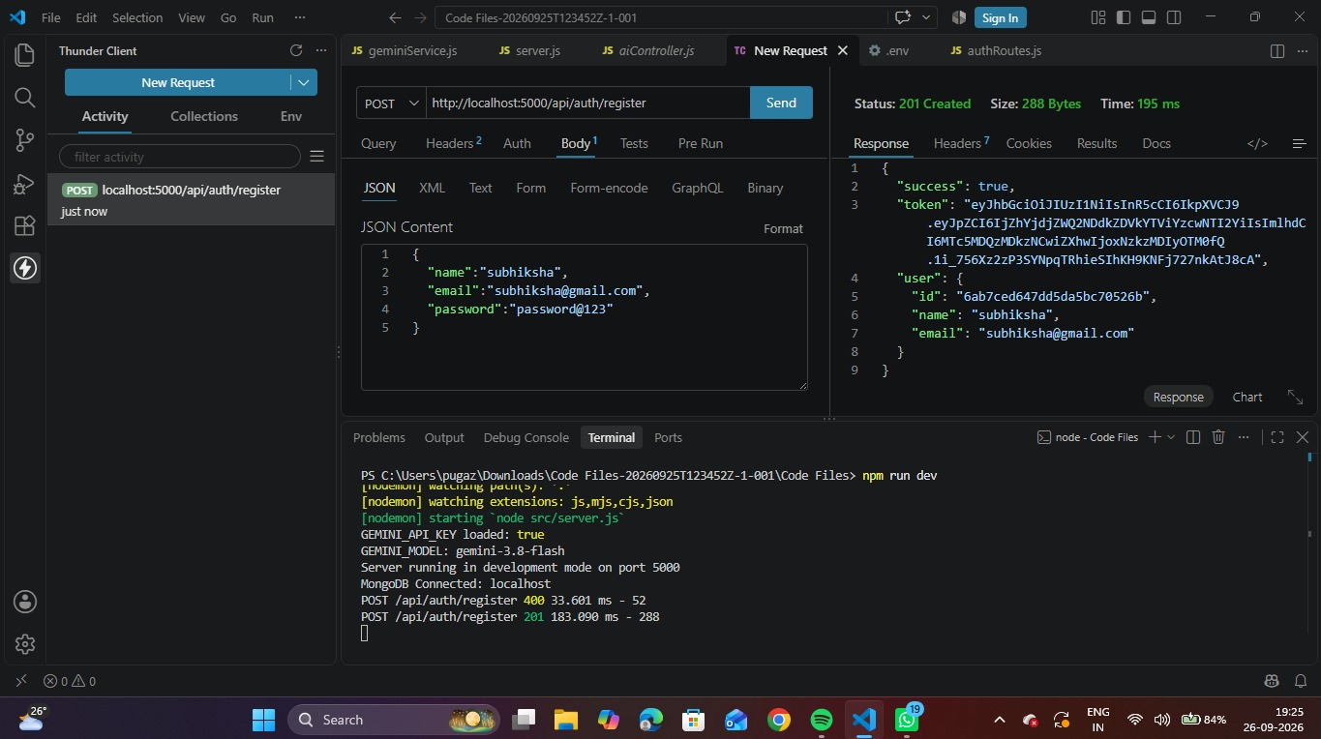

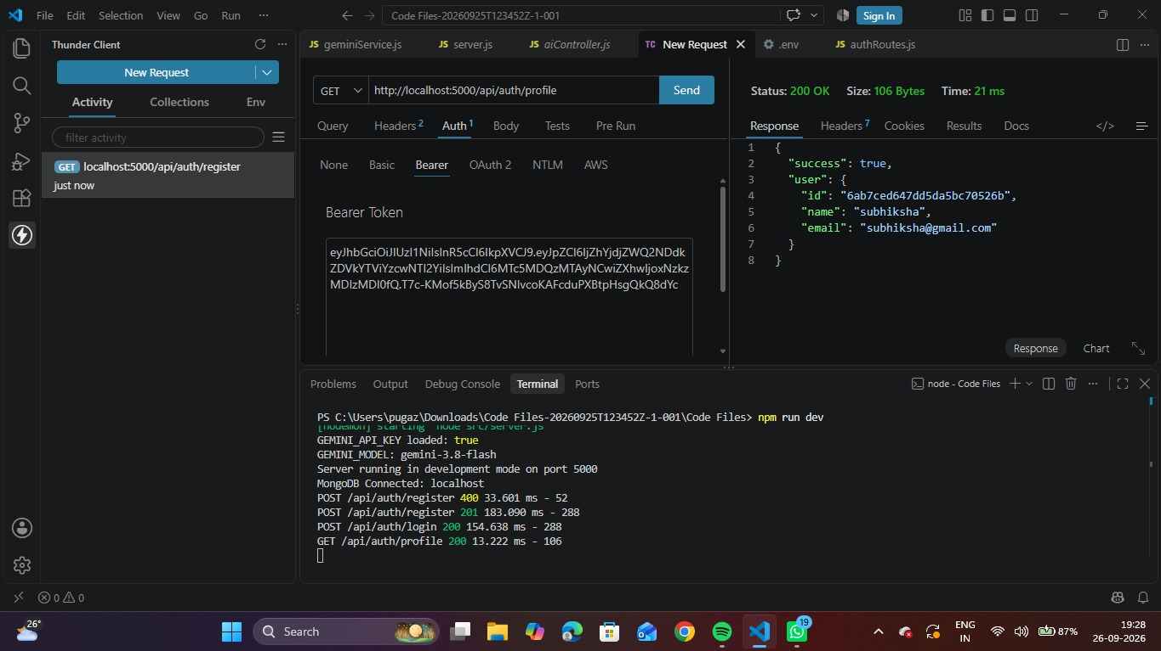

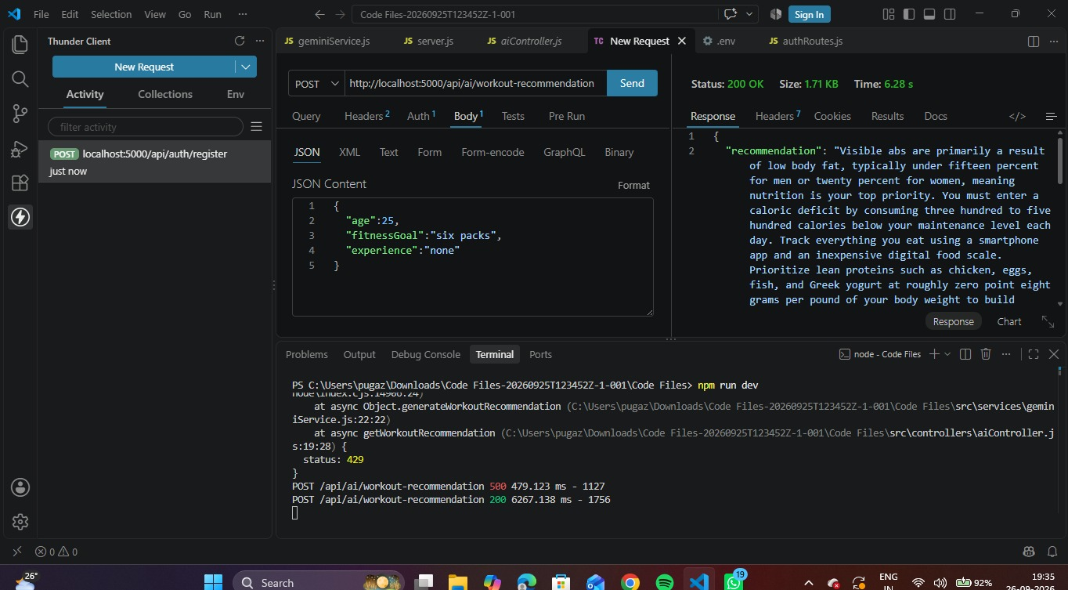
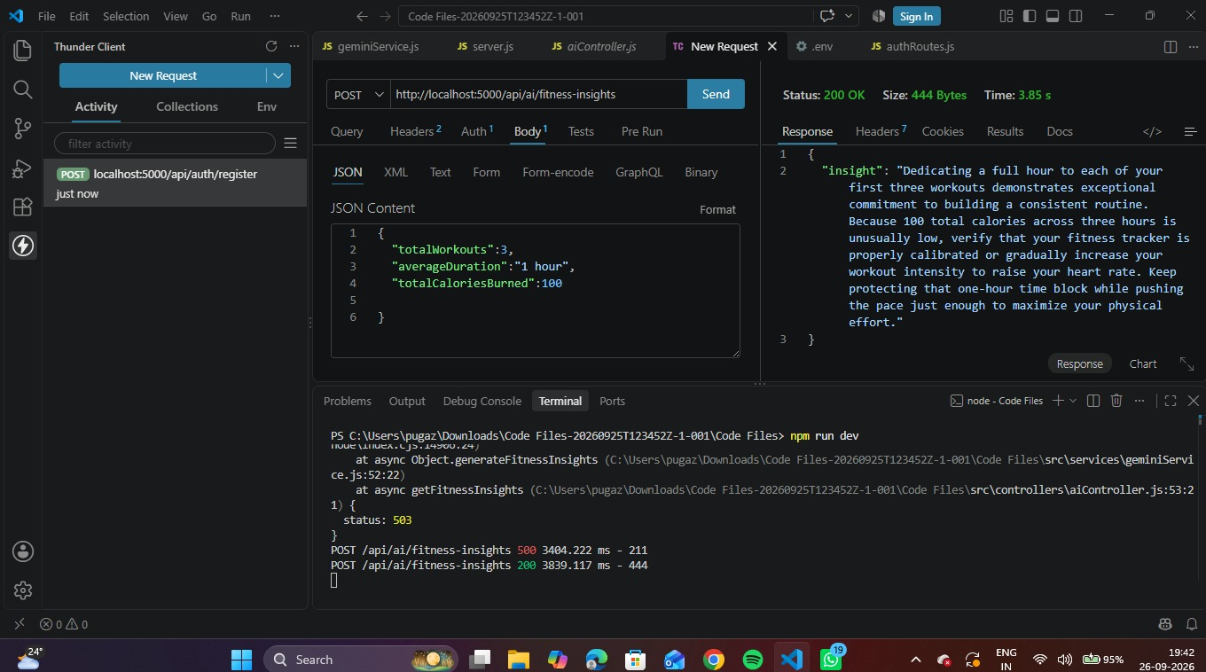
3. DEMO LINK
https://drive.google.com/drive/folders/19tT0LkS34ZJ6y5aA_GlgbjmLW-6Ly-3Y?usp=sharing

